Logan Hammond

14 January 2020

SDEV 300, Fair

# Lab 1 Application Tests

# MinMax Results

|  |  |  |  |  |
| --- | --- | --- | --- | --- |
| Test Case | Input | Expected Output | Actual Output | Pass? |
| 1a | 1,2,3,4,5 | 1,5 | 1,5 | Yes |
| 1b | 5,4,3,2,1 | 1,5 | 1,5 | Yes |
| 1c | -1,-2,-3,-4,-5 | -5,-1 | -5,-1 | Yes |
| 1d | -5,-4,-3,-2,-1 | -5,-1 | --5,1 | Yes |
| 1e | 1,2,3,4,f | Error | Error | Yes |

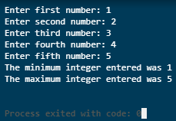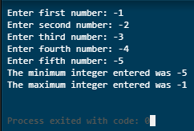

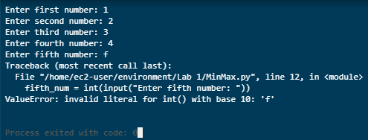

# Calculator Results

## Addition

|  |  |  |  |  |
| --- | --- | --- | --- | --- |
| Test Case | Input | Expected Output | Actual Output | Pass? |
| 1a | 1, 2 | 3 | 3 | Yes |
| 1b | 1, -2 | -1 | -1 | Yes |
| 1c | -1, 2 | 1 | 1 | Yes |
| 1d | -1, -2 | -3 | -3 | Yes |
| 1e | 1, f | Error | Error | Yes |

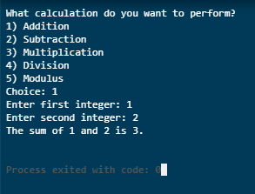 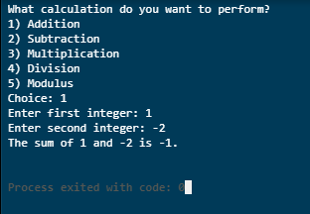

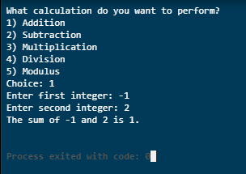 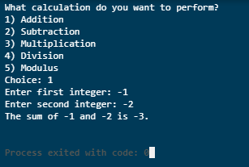

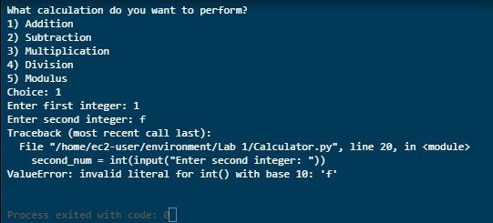

## Subtraction

|  |  |  |  |  |
| --- | --- | --- | --- | --- |
| Test Case | Input | Expected Output | Actual Output | Pass? |
| 1a | 1, 2 | -1 | -1 | Yes |
| 1b | -1, 2 | -3 | -3 | Yes |
| 1c | 1, -2 | 3 | 3 | Yes |
| 1d | -1, -2 | 1 | 1 | Yes |
| 1e | 1, f | Error | Error | Yes |

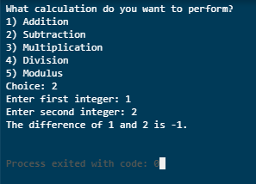 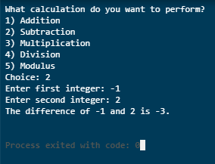

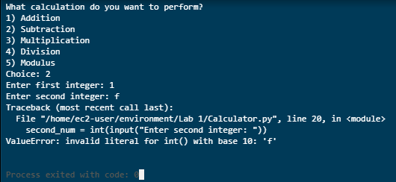

## Multiplication

|  |  |  |  |  |
| --- | --- | --- | --- | --- |
| Test Case | Input | Expected Output | Actual Output | Pass? |
| 1a | 1,2 | 2 | 2 | Yes |
| 1b | -1,2 | -2 | -2 | Yes |
| 1c | 1,-2 | -2 | -2 | Yes |
| 1d | -1,-2 | 2 | 2 | Yes |
| 1e | 1,f | Error | Error | Yes |

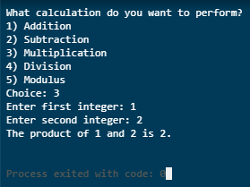 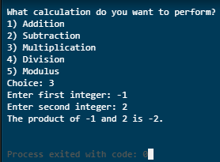

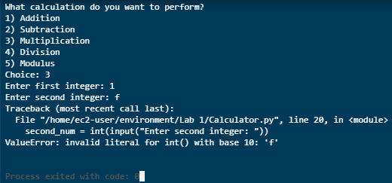

## Division

|  |  |  |  |  |
| --- | --- | --- | --- | --- |
| Test Case | Input | Expected Output | Actual Output | Pass? |
| 1a | 4,2 | 2.0 | 2.0 | Yes |
| 1b | -4,2 | -2.0 | -2.0 | Yes |
| 1c | 4,-2 | -2.0 | -2.0 | Yes |
| 1d | -4,-2 | 2.0 | 2.0 | Yes |
| 1e | 4,0 | Error | Error | Yes |
| 1f | 4,f | Error | Error | Yes |

## 

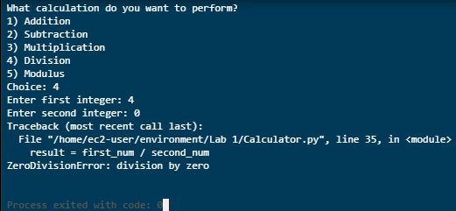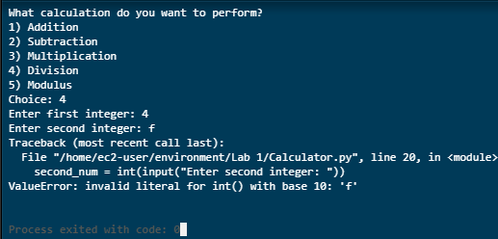

## Modulus

|  |  |  |  |  |
| --- | --- | --- | --- | --- |
| Test Case | Input | Expected Output | Actual Output | Pass? |
| 1a | 5,10 | 5 | 5 | Yes |
| 1b | 10,5 | 0 | 0 | Yes |
| 1c | 5,-10 | -5 | -5 | Yes |
| 1d | -5,-10 | -5 | -5 | Yes |
| 1e | 5,f | Error | Error | Yes |

## 

